**Design Document for ACME TEST Application RPA Automation**

**1. Project Overview**  
This project automates a business process in the ACME TEST application using UiPath. The automation extracts work items, processes invoices, updates statuses, calculates fees, and emails the final report.

**2. Prerequisites**

* UiPath Studio installed (2021.10 or later recommended)
* UiPath Excel, Mail, and System activities packages installed
* Valid credentials for ACME System 1
* Stable internet connection
* Configured Outlook or SMTP settings for email functionality
* Folder structure in place for saving invoices and reports
* Dependencies restored via UiPath Project Dependencies
* Create your account on https://acme-test.uipath.com

**3. Workflow Diagram**

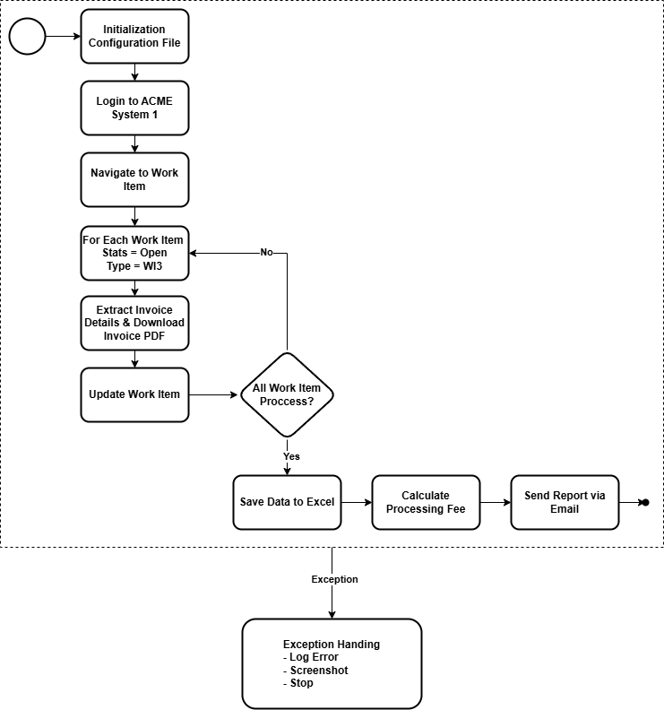

**4. Automation Steps**

**Step 1: Login to ACME System 1**

* Navigate to [https://acme-test.uipath.com](https://acme-test.uipath.com/).
* Enter credentials and log in.
* Handle incorrect credentials by displaying an error message and retrying.
* If login fails after 3 attempts, go to **Exception Handling**.

**Step 2: Extract Work Items**

* Navigate to the Work Items page.
* Use data scraping to extract open WI3 work items, including:
  + WIID
  + Description
  + Type
  + Date

**Step 3: Extract Invoice Details & Download Invoice**

* Max retry is set at 3 for the following items
* For each work item that status is “Open”, and type is “WI3”
* click action icon to open invoice details.
* Extract:
  + Invoice ID
  + Amount
  + Currency
* Download and save the invoice as WIID - InvoiceID.pdf in a dynamically named folder (YYYYMMDD).
* If an invoice fails to download, go to **Exception Handling**.
* Click “Update Work Item” set the comment field to "Processed by UiPath".
* Mark status as ‘Completed’ and submit the update.
* If updating the work item fails, go to **Exception Handling**.

**Step 5: Save Extracted Data to Excel**

* Save extracted data in Processed_WorkItems_<DateTime>.xlsx.
* Columns:
  + WIID
  + Description
  + Type
  + Date
  + Invoice ID
  + Amount
  + Currency
* If data saving fails, go to **Exception Handling**.

**Step 6: Calculate Processing Fee**

* Add two new columns:
  + Processing Fee = 5% of Amount
  + Total Amount = Amount + Processing Fee

**Step 7: Send Report Over Email**

* Zip all downloaded PDF invoices.
* Attach the final Excel report.
* Email content:
  + Total number of processed work items.
  + Sum of Amount.
  + Sum of Processing Fee.
  + Sum of Total Amount.
* Send to the User.
* If the email fails, go to **Exception Handling**.

**5. Exception Handling**

* Log the error.
* Screenshot of current error

**6. Test Cases Document**

|  |  |  |  |
| --- | --- | --- | --- |
| **Test Case ID** | **Scenario** | **Expected Result** | **Status** |
| TC01 | Login with valid credentials | Login successful | Pass |
| TC02 | Login with incorrect credentials | Error message displayed | Pass |
| TC03 | Extract WI3 work items | Work items extracted | Pass |
| TC04 | Extract invoice details | Invoice details extracted | Pass |
| TC05 | Download invoices | PDFs saved in YYYYMMDD folder | Pass |
| TC06 | Update work item status | Work item marked Completed | Pass |
| TC07 | Save data to Excel | Excel file saved with correct columns | Pass |
| TC08 | Calculate Processing Fee | Correct fees calculated | Pass |
| TC09 | Send Email | Email sent with attachments | Pass |
| TC10 | Failure Handling Triggered | Failure notification email sent | Pass |

**7.** **Configuration File Details**

|  |  |
| --- | --- |
| **Name** | **Value** |
| TargetURL | [https://acme-test.uipath.com](https://acme-test.uipath.com/) |
| ACME_Credentials | ACME System 1 Login |
| Max_Retry | 3 |
| Output_File | C:\Users\franc\Documents\UiPath\WorkItemProcessing\Data\Output\ |
| Process_Email | franciskoh95@gmail.com |
| Email_To | franciskoh95@gmail.com |
| Archive_Folder | C:\Users\franc\Documents\UiPath\WorkItemProcessing\Data\Achive\ |
| Exception_Folder | C:\Users\franc\Documents\UiPath\WorkItemProcessing\Data\Exception\ |
| Gmail_Credentials | Gmail |

**8. Best Practices**

* Use **Config File** for credentials, folder paths, and URLs.
* Implement **Retry Scopes** where necessary.
* **Logging** at each critical step for tracking errors.
* **Error Handling Framework** to manage failures gracefully.

This document outlines the entire UiPath automation process for the ACME TEST case study, ensuring efficiency and accuracy in execution.